Prototype-CPL

|  |  |
| --- | --- |
| **Student Name/ID Number:** | Francis Roel L. Abarca – BDSE-0922-113 |
| **Academic Year:** | 2022-2023 |
| **Unit Assessor:** | Arvinder Kaur – Mentor |
| **Project Title:** | CPL-Project prototype |
| **Issue Date:** | 9/5/2023 |
| **Submission Date:** | 9/6/2023 |
| **Internal Verifier Name:** | Arvinder Kaur |
| **Date:** | 9/6/2023 |

|  |
| --- |
| **Learner declaration** |
| I certify that the work submitted for this assignment is my own and research sources are fully acknowledged.    9/6/2023  Student signature: Date: |

Login Page

* Desktop (1920x1080) 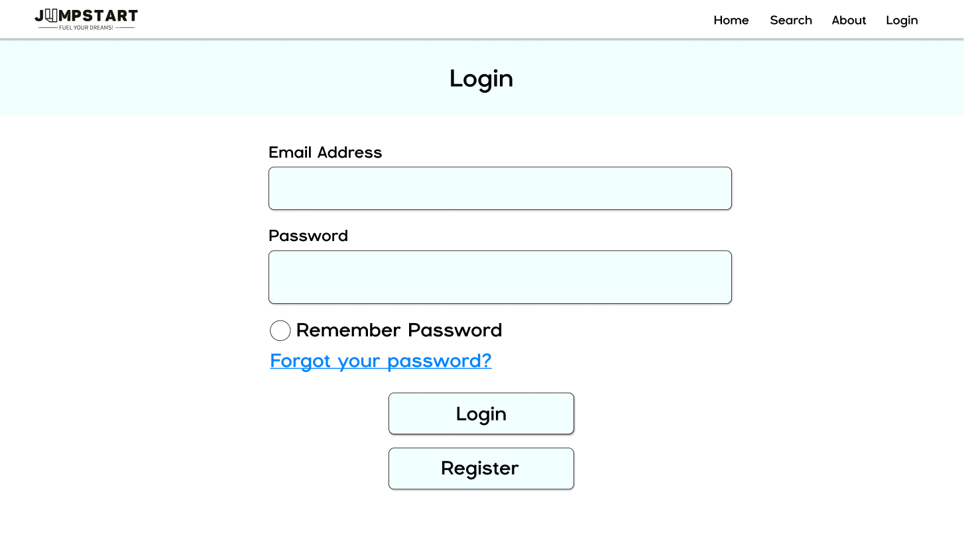
* Mobile (1080x1920)  
   A screenshot of a login form

  Description automatically generated

Registration Page

* Desktop (1920x1080) A screenshot of a register form

  Description automatically generated
* Mobile (1080x1920)  
   A screen shot of a login form

  Description automatically generated

Shopping Center (Home Page)

* Desktop (1920x1080)  
  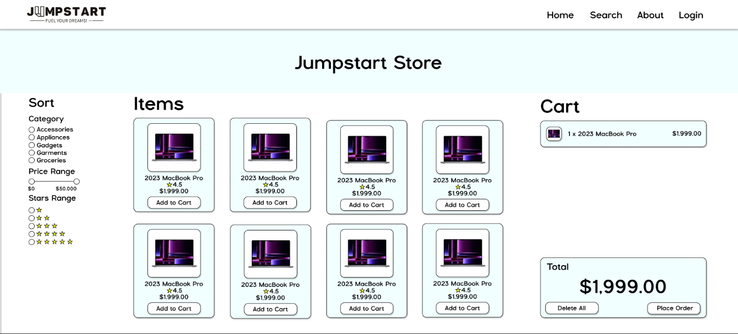
* Mobile (1080x1920)  
   A screenshot of a phone

  Description automatically generated

Chat Page

* Desktop (1920x1080) A screenshot of a chat

  Description automatically generated
* Mobile (1080x1920)  
   A screenshot of a chat

  Description automatically generated

Product Page

* Desktop (1920x1080) 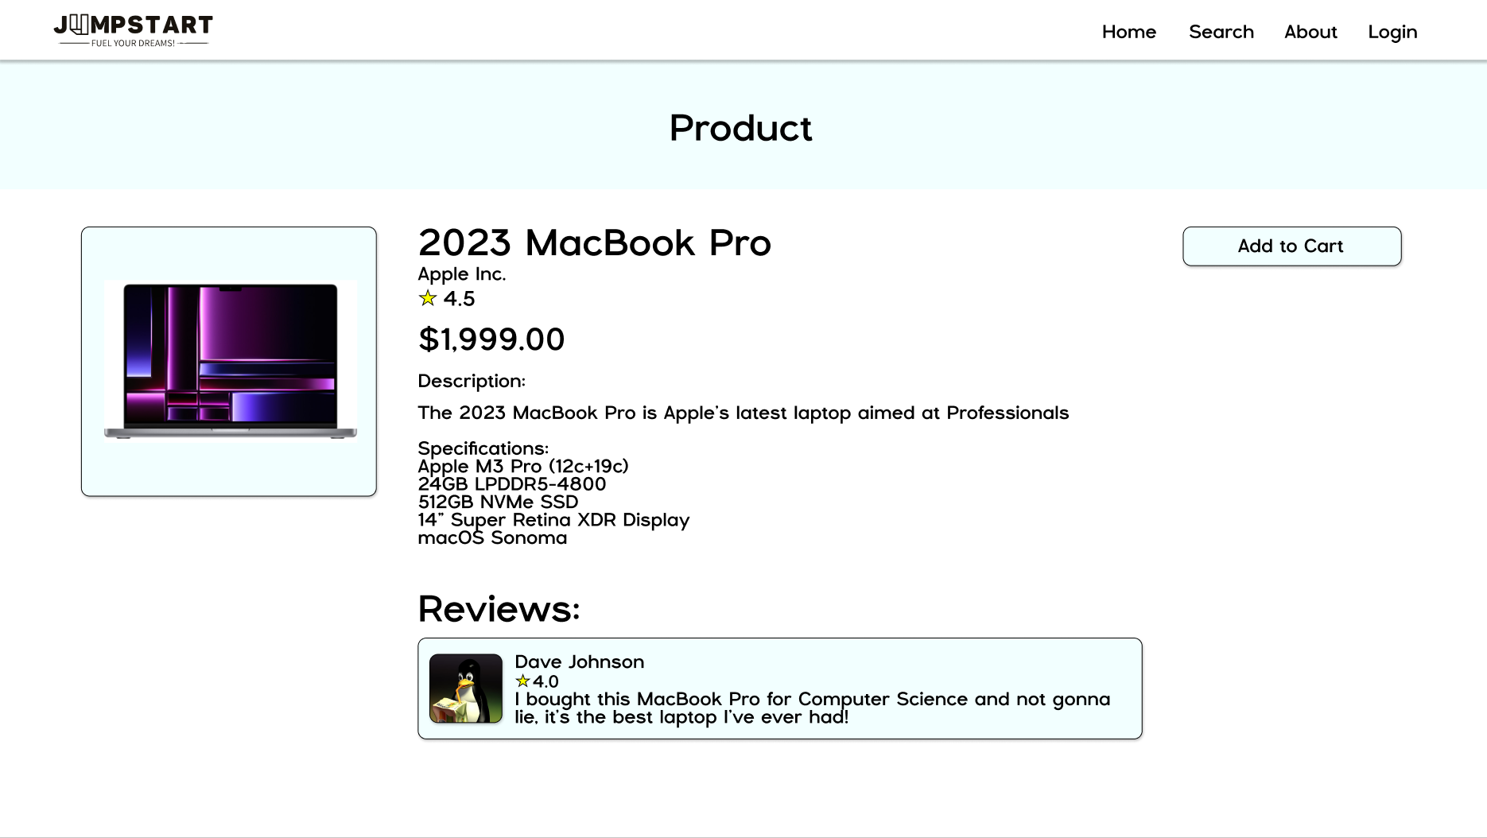
* Mobile (1080x1920)  
   A screenshot of a computer

  Description automatically generated

Order History

* Desktop (1920x1080) A screenshot of a computer

  Description automatically generated
* Mobile (1080x1920)  
   A screenshot of a phone

  Description automatically generated